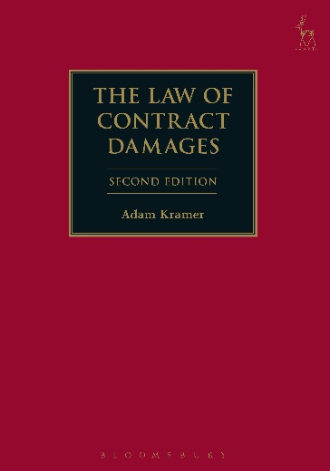**SECOND EDITION**

**The Law of Contract Damages**

*Adam Kramer*

Written by Adam Kramer, a commercial barrister and academic, the second edition of the acclaimed The Law of Contract Damages is the most comprehensive and detailed treatment available of this important dispute resolution area. The first edition is regularly cited in the courts and academic literature, and this new edition has been substantially updated to take account of over 150 recent decisions.

To aid understanding and practicality of use, the book is primarily arranged by the type of complaint, such as the mis-provision of services, the non-payment of money, or the temporary loss of use of property, but also includes sections on causation, remoteness and other general principles. At all points, the work gathers together the cases from all relevant contractual fields, both those usually considered—construction, sale of goods, charterparties, professional services—and those less frequently covered in general works—such as SPAs, insurance, and landlord and tenant. It also refers to tort decisions where relevant, including full coverage of professional negligence damages, and gives detailed explanation of many practically important but often neglected areas, such as damages for lost management time and the proof of lost profits.

The book provides authoritative and insightful analysis of damages for breach of contract and is an essential resource for practitioners and scholars in commercial law and other contractual fields.

***Adam Kramer*** *is a barrister at 3 Verulam Buildings. He was previously a lecturer in law at the Universities of Durham and Oxford.*

November 2017 | 9781509915842 | 696pp | Hardback | RSP: ~~£100~~

**Discount Price: £80**

**Order online at** [**www.hartpublishing.co.uk**](http://www.hartpublishing.co.uk) **and use the code ODG at the checkout to get 20% off your order**